1, Introduction:
Topic: Business Statistics: Use Regression Analysis to Determine Validity of Relationships
A statistics analysis is widely used in all aspects such as in science, medicine, business and finance. There are many methods in statistics to study the relation between or among different factors. One of important methods is regression. The logarithm regression line and T-test were selected to build a model of stock market. (oil price and delta, Mattel) The main objective in this paper is to select the suitable controlled variables to study their relationships.

2, Research Goal and questions
Use statistics to analyze oil price as a common factor to affect the major Airlines Stock Market in USA.
Use statistics relationship to explain why Mattel went down suddenly and later went up.
What reasons cause Mattel stock went down so much?
What kind of relationship between oil price and Airlines Stock Market?

3. background
Academic background: (focus on regression analysis? Correlation and Causility)
Regression analysis is one of the most important statistical techniques as business applications. It's a statistical methodology that helps estimate the strength and direction of the relationship between two or among more variables. The analyst may use regression analysis to determine the actual relationship between various variables by looking at a company’s stock price affected another company’s stock over the past several years. The regression results show whether this relationship is valid. Use regression analysis to estimate historical relationships among different financial assets.
Correlation is a statistical measure (expressed as a number) that describes the size and direction of a relationship between two or more variables. A correlation between variables, however, does not automatically mean that the change in one variable is the cause of the change in the values of the other variable.
Causation indicates that one event is the result of the occurrence of the other event; i.e. there is a causal relationship between the two events. This is also referred to as cause and effect.

A statistical hypothesis is an assumption about a population parameter. This assumption may or may not be true. Hypothesis testing refers to the formal procedures used by statisticians to accept or reject statistical hypotheses.
- Null hypothesis. The null hypothesis, denoted by H₀, is usually the hypothesis that sample observations result purely from chance.
- Alternative hypothesis. The alternative hypothesis, denoted by H_{a}, is the hypothesis that sample observations are influenced by some non-random cause.
A T-test is an analysis of two population means through the use of statistical examination; a T-test with two samples is commonly used with small sample sizes, testing the difference between the samples when the variances of two normal distributions are not known.
When we assume a normal distribution exists, we can identify the probability of a particular outcome. We specify the level of probability (alpha level, level of significance, p) we are willing to accept before we collect data (p < .05 is a common value that is used). After we collect data we calculate a test statistic with a formula. We compare our test statistic with a critical value found on a reference table in appendix to see if our results fall within the acceptable level of probability.

Mattel (causality)
(1) initial data
Here we collected data from yahoo finance http://www.nasdaq.com/symbol/mat/historical from1/3/ 2012-12/31/2015

Table 1 :

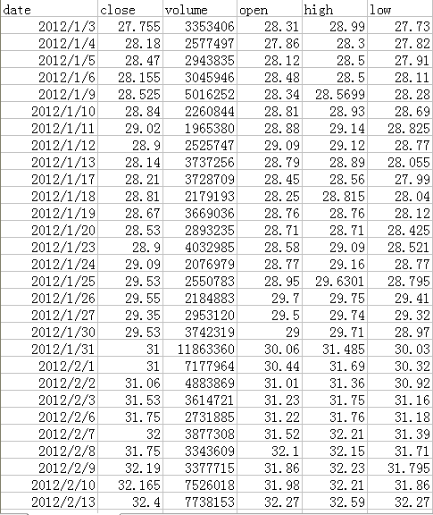
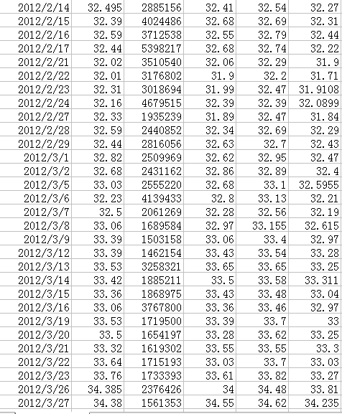

(2)Data description
Chart 1: this is the chart which the data is from 2012-2015
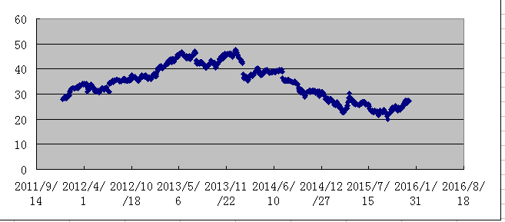
From this chart we can easy to see that it increases between 2012-2013, but why suddenly, it drop a lot after 2013, and it lasts 2 years?
Reasons, Mattel lose contract with Disney after 2013 which cased Mattel stock market dropping.
http://money.cnn.com/2014/09/25/news/hasbro-frozen-disney/

From 1/3/2012 to 09/25/2014, the mean value of Mattel is 38.324, and from 9/26/2014 to 12/31/2015, the mean value of Mattel is 26.348. We can easy to see that these two periods’ mean values are so much different. And also, the standard deviation is 4.746, in period one but 2.933 in second period. The standard deviations in that two periods are difference, that’s why we use T-test for two independence samples. In finance, standard deviation is applied to the annual rate of return of an investment to measure the investment's volatility. The smaller an investment's standard deviation, the less volatile it is. The larger the standard deviation, the more dispersed those returns are and thus the riskier the investment is. The higher standard deviation means higher-risk, higher-yield.

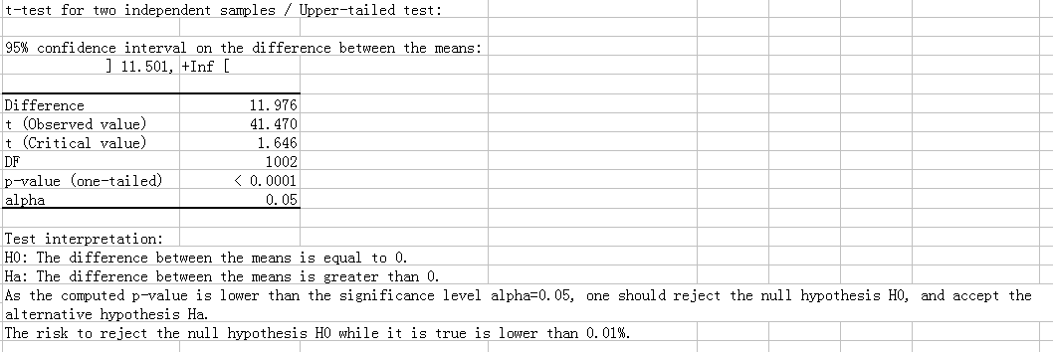

Doing the hypothesis testing:
The null hypothesis is H0: The difference between the means is equal to 0.
The alternative hypothesis is Ha: The difference between the means is greater than 0.
95% of the confidence interval is our assumption, which means the significant level is 5%. The difference is between the mean value(38.324-26.348=11.976). Observed value 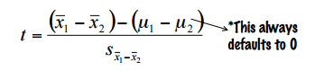
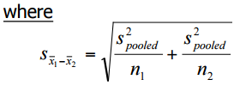
Critical value is base on the alpha and the degree of freedom(DF) so that we can check the table and find it the t critical value is 1.646. and we can get the P value is less than alpha= 0.05

